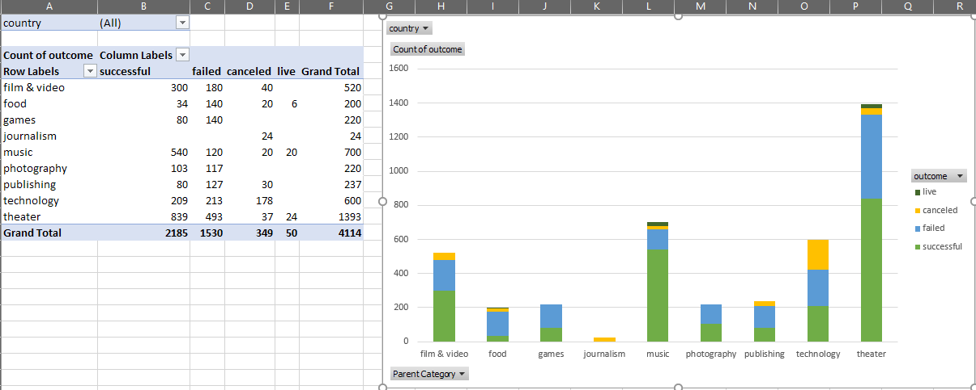

1. With the data collected for this Kickstarter data project and the resulting charts and tables drawn from the data, we are able to make a few conclusions about trends in Kickstarter. One is that a majority of Kickstarter campaigns originate in the entertainment industry. These categories include film & television, theater, and music, which also happened to be the 3 leading categories for the overall total campaigns. A second conclusion that we are able to reach is that the technology industry is more volatile in terms of campaigns either failing or being cancelled before they are able to reach their funding goal. The third conclusion is that Kickstarter campaigns seem to be more successful in the beginning of the year, and campaigns that start later on in the year tend to lose support or cancel before they are completed
2. While this dataset is pretty comprehensive in terms of general data regarding Kickstarter campaigns, it does have some limitations that make some of the data unclear or ambiguous unless we are given additional factors. For example, the data does not show the amount of advertising that went into each campaign, which in real life is a huge factor in whether campaigns gain enough traction to complete their goal. Another field of data that is missing is if the campaign creator has previously led other funding campaigns, or contributed and/or collaborated in other campaigns.
3. The data presented can be arranged in some additional charts that show different trends. For example, if you wanted to see if the amount of the funding goal contributed at all to whether it was successful or not, you can create a pivot table which shows the goal amount vs. the outcome of the campaign. Also, if you wanted to see if the number of contributors vs. the outcome showed any trends, you could create a stacked bar chart showing the correlation.